**RADIX SORTING ALGORITHM**

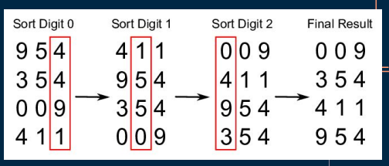● Radix sort can be dated back in 1887 by Herman Hollerith with the tabulating machines.

● Radix sorting algorithm can be traced to Harold H. Seward in 1954

● Considered as a stable sort

● An out-of-place algorithm

**ALGORITHM**

**VARIATIONS**

**LSD Radix Sort**

○ LSD = least significant digit

○ Sorting of digits starting from the least significant to most significant digit.

**MSD Radix Sort**

○ MSD = most significant digit

○ Sorting of digits starting from the most significant digit

**TIME AND SPACE COMPLEXITY**

